## Reset Buttons

### Specification

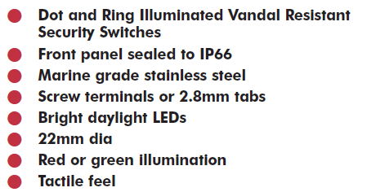

Figure 2‑45: Specifications

### Installation

The illuminated switches can be used to provide pushbuttons that can be used to reset the BNWAS timer. By holding the pushbutton for more than 3 seconds, the emergency alarm will be triggered. This way we have an emergency call button at all stations and the button is tamper-proof.

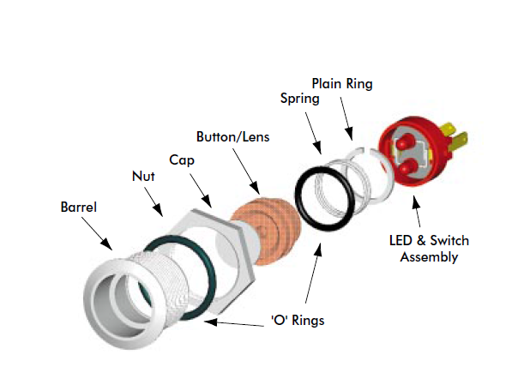

Figure 2‑46: Bulgin security switch-illiminated